

A Minor Project - II Report on

SUPER MARKETING IN ADVANCED TECHNOLOGY

Submitted by

RAM PRAKASH S (927622BEE086) SAPREENA S (927622BEE099)

SRINIDHI B (927622BEE114)



DEPARTMENT OF ELECTRICAL AND ELECTRONICS ENGINEERING M.KUMARASAMY COLLEGE OF ENGINEERING
(An Autonomous Institution Affiliated to Anna University, Chennai) THALAVAPALAYAM, KARUR-639113.

DECEMBER 2023

ABSTRACT

The Smart Shopping Cart project aims to revolutionize the traditional shopping experience by integrating advanced technologies to create a more efficient and user- friendly retail environment.This system leverages Internet of Things (IoT) and artificial intelligence to enhance the functionality of shopping carts, providing both customers and retailers with innovative features. Key Features of the Smart Shopping Cart System. Automated item tracking, Intelligent shopping assistance Automated Item Tracking: The shopping cart is equipped with RFID (Radio-Frequency Identification) or NFC (Near Field Communication) technology to automatically identify and track items as they are placed into or removed from the cart. This feature eliminates the need for manual bar code scanning and enhances the speed and accuracy of the shopping process. Intelligent Shopping Assistance is an integrated display on the cart provides real-time product information, including prices. Virtual Shopping Lists Customers can create and manage virtual shopping lists through a mobile app, and the cart intelligently guides them through the store to locate items efficiently.The system can optimize the shopping route to save time and enhance the overall shopping experience. Contact less Payment Integration Seamless integration with digital payment systems allows customers to complete transactions directly from the shopping cart, reducing checkout time and enhancing convenience.Payment information is securely processed, providing a friction less payment experience. Anti- Theft measures the system includes anti-theft features such as weight sensors and RFID/NFC validation to ensure that all items are properly scanned and paid for before leaving the store. Alarms and alerts are triggered for any discrepancies, enhancing security.Data analytics for Retailers have access to analytics and insights derived from customer shopping patterns, helping them optimize store layouts, product placements, and promotions. The system contributes to data-driven decision- making for marketing strategies.

Survey form sample

CHAPTER 1
SURVEY FORM ANALYSIS

NAME AND ADDRESS OF THE COMMUNITY:
R.Rajasekar ,Ravi super market ,karur.

AGE GROUP :
36 Years to 50 years

DISCUSSION :
  - What? (Define the problem)
During the bill section the customers rejecting the some products as side as table.

Why? (Reason for the problem occurrence)
The consumers does not know the exact amount and they do not have efficient amount to buy the products.

When? (when the problem began or first noticed)
While the consumer are purchasing in the super market.

Where? (Place of the problem) first occurrence or sighting)
While I am purchasing the stationery things in super market I noticed the problem including me and family members.

Who? ( The person or thing that the problem effects)
The problems affects to the consumer

How (The sequence of events that resulted in the problem)
If have been rectified in the super marketing in advanced technology by counting the amount in trolley itself

Signature of the surveyee

- Which? (People have attempted to solve the issue)
Yes

Does the problem appear to have only one possible solution?
Yes, it is the only one solution in this method.

Work plan of the project
To create a device which intimate the customer to purchase the products
easily

Final Solution
The final solution is the customer can now easily calculate the amount of product while purchasing in trolley itself by qr scanner which is placed n the trolley which will display in lcd display board and this instruments were connected in the trol

Chapter 1.2

SURVEY FORM ANALYSIS

- Name and address of the community:
R.Rajasekar ,Ravi super market ,karur.

Problem identification :
Customers are facing so many problem in pay section in super market due to they don’t know the exact amount of the product which they have taken by using the project method we can rectify these problem .

CHAPTER 2 LITERATURE REVIEW
Paper1 : SMART SHOPPING CART WITH AUTOMATIC BILLING SYSTEM THROUGH RFID AND ZIGBEE
Authors : P. Chandrasekar, T.Sangeetha
Published in : International conference on information communication and embedded systems ( ICICES2014)
Inference: This paper suggests a method that is based on the RFID and ZigBee which creates an automated central billing system for the shopping malls. eliminating the queues and displaying the real-time price of the items in the cart.

Paper2: RFID BASED ON SMART SHOPPING AND BILLING
Authors : Zeeshan ali, prof.reena sonkusare
Published in : IEEE conference 2013
Inference : In this paper, more utilization of LCD like removing the item by cancel button on LCD implemented. It explains how to access real-time information about the diverse products inside the shopping cart.

paper3: INNOVATIVE SHOPPING CART FOR SMART CITIES
Authors: Prasiddhi k, Dhanashree , H.Gawali
Published in : IEEE Conference 2017
Inference : The proposed system consists of some new smart features incorporated compared to other systems. Here provision is made for a truly beneficial budget setting. Customers will get the real time statistics/condition/information of the product which will ultimately help them to choose a best suited product for their needs.

Paper 4: AUTOMATION PRODUCT DETECTION AND SMART BILLING FOR SHOPPING USING LIGHT-FIDELITY
Authors : Ezhil Azhagan , R.Adithya, Y.L.Burhanuddin , F.charles
Published in : IEEE Conference 2016
Inference : It has features incorporated with automatic recognition of products by means of optical fibers using LiFi technology. The payment is processed through mobile bankingomoney payment and therefore the cart system can verify the products and complete the transaction successfully.

DESCRIPTION
A smart shopping cart is an innovative concept that combines technology with traditional shopping to enhance the overall shopping experience. The primary goal of a smart shopping cart is to streamline the shopping process, improve efficiency, and provide a more convenient and enjoyable experience for consumers. A description of the key features and components that could be included in a smart shopping cart project. Automatic Item Recognition: As items are placed in the cart, the smart system can automatically recognize and add them to the cart's digital inventory.The cart is equipped with a touchscreen interface that allows users to interact with the system. Users can view their shopping list, check prices, and access information about products through the cart's interface Bar code Scanner: A built-in bar code scanner allows users to scan items for detailed their smartphones with the smart cart through a dedicated mobile app. The app may provide features such as creating shopping lists, receiving personalized promotions, and tracking purchases. Automated Checkout:The smart cart can facilitate a seamless checkout process .Integrated payment options allow users to pay directly from the cart, reducing the need to wait in traditional checkout lines. Product Recommendations: Based on the user's purchase history and preferences, the smart cart can suggest additional products to enhance the shopping experience. Real-Time Analytics: The system can provide real-time analytics to store managers, helping them understand customer behaviour , popular products, and optimize inventory management. Implementing a smart shopping cart system can significantly enhance the efficiency of the shopping process, improve customer satisfaction. It is also improved many times according to requirements of sellers and customers. It does the same work that is calculating the bill, gives it to the customer and maintain proper database. They are accurate in calculation and printing, they also generate. The billing system is built to help supermarkets calculate and display bills and serve the customer in a faster and efficient manner. This software project consists of effective and easy

PROJECT KIT PHOTO GRAPH

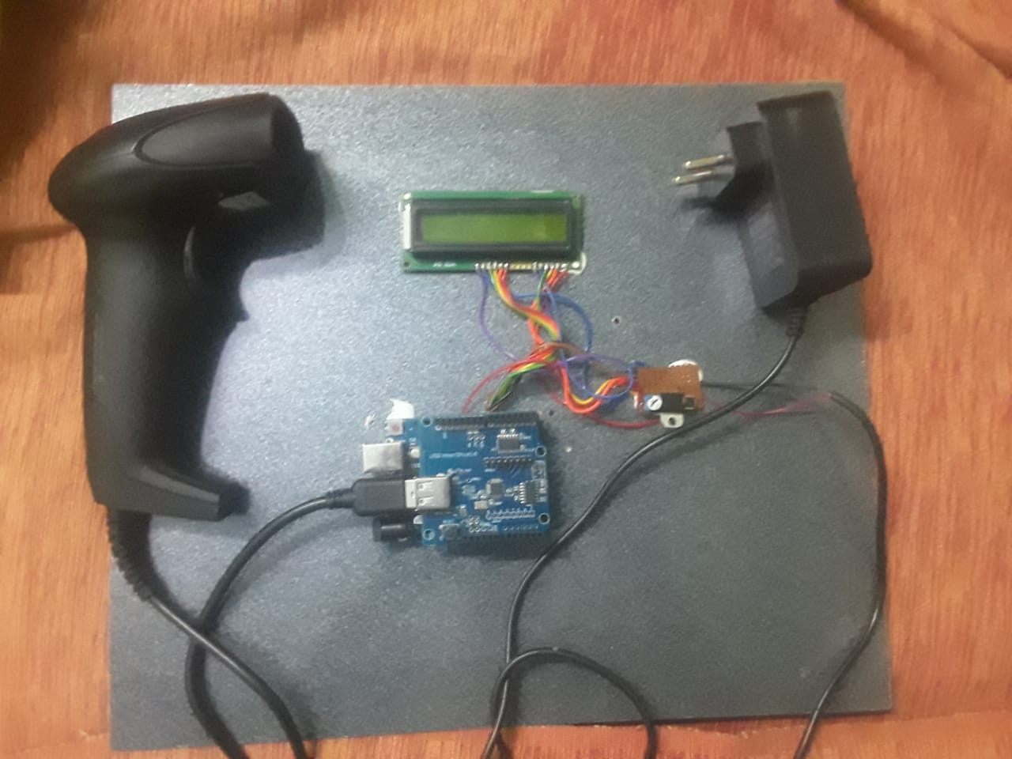

PROPOSED METHODOLOGY

3.1 BLOCK DIAGRAM

LCD DISPLAY OUTPUT AURDINO BOARD

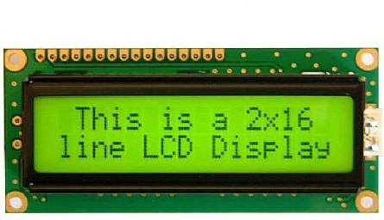

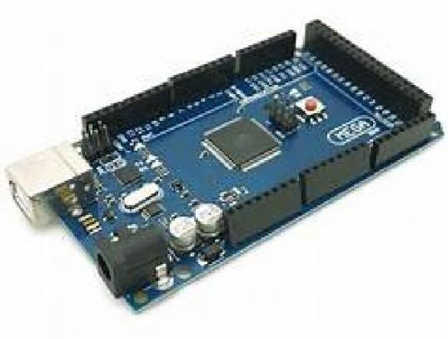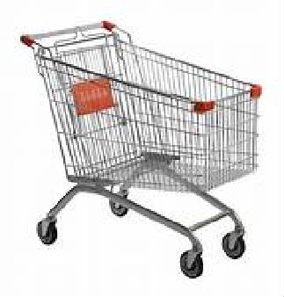TROLLEY

PROCESSING UNIT
QR SCANNER

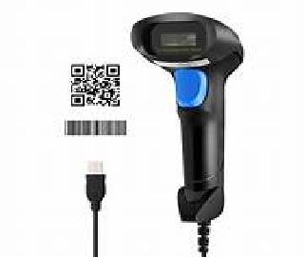
INPUT

CHAPTER 3

3.3 COST ESTIMATION

S.NO | COMPONENTS DESCRIPTION | QUANTITY | COST
1. | Trolley (From reuseable material) | 1 | 200
2. | QR code scanner | 1 | 1300
3 | LCD display board | 1 | 255
4. | Arduino components | 1 | 813
 | TOTAL |  | 2568

CHAPTER 4
FUTURE SCOPE & ITS IMPLEMENTATION PLAN

AI-Powered Recommendation System:
Uses machine learning algorithms to analyze people's preferences, purchasing history and behavior.
Increase sales and sales by sending personalized recommendations via mobile app or in-store.444

Computer Vision for Seamless Payment:
Integrated computer vision technology for seamless or hassle-free payment.
The automatic system allows quick and easy payment by identifying and counting the items in the customer's shopping cart.

IoT integration for shopping engagement:
Use Internet of Things (IoT) devices to create a connected shopping experience. Smart shelves with sensors can monitor and restock product levels, reducing out-of- stocks.

Mobile Apps to Increase Engagement:
Create feature-rich mobile apps that leverage augmented reality (AR) for virtual tryons or product demonstrations.
Location-based services can offer customers personalized promotions and discounts as they browse the store.

Blockchain supports chain transparency:
Use blockchain to improve chain visibility and traceability.
Customers can verify product authenticity, transparency and trust in the supply chain.

Data Analytics for Business Insights:
Use advanced analytics tools to analyze customer profiles, purchasing patterns, and store performance.
The knowledge gained can enable better decisions, improve inventory management, and improve overall business performance.444

Speech and Natural Language Processing (NLP):
Combining speech recognition and NLP for hands-free marketing. Customers can use voice commands to find products, get information or add products to the shopping list.

Robot Assistance:
Explore the use of robots to perform tasks such as managing inventory, stocking shelves, or providing customer service.
Robots can increase productivity and create a futuristic economy.

Cyber Security Measures:
Use strong cyber security measures to protect customer information and ensure the security of the store.
Since this project involves the processing of sensitive information, it is important to pay attention to information security.

Sustainability Initiatives:
Consider environmentally friendly behaviors such as reducing waste packaging or encouraging product choice.
Use technology to educate consumers about the environmental impact of their purchases.Continuous monitoring of the progress of technology and consumer products is important for timely updating and improvement of smart products,.

IMPLEMENTATION PHOTOGRAPH
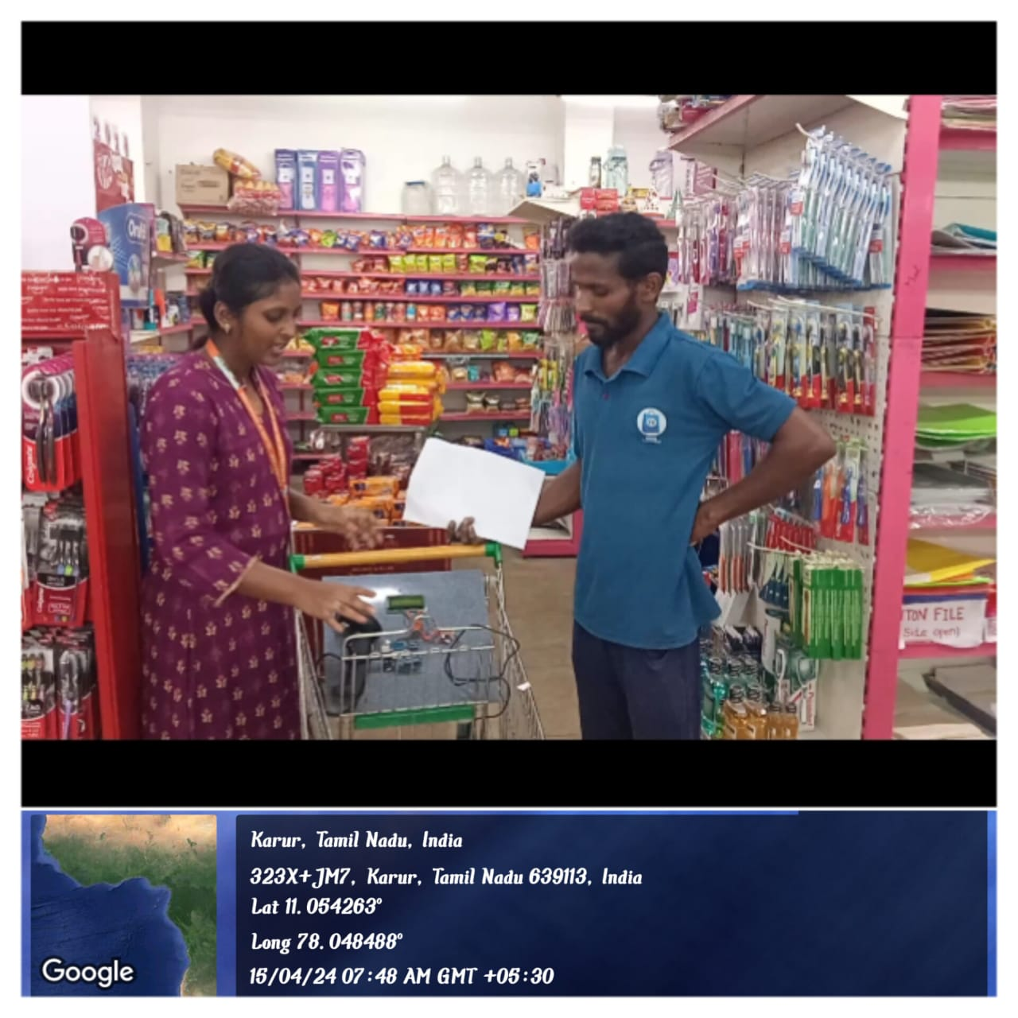

REFERENCE :

- 1) Prasiddhi K, Dhanashree H. Gawali, Innovative shopping cart for smart cities”, 2017 2nd IEEE International Conference On Recent Trends in Electronics Information & Communication Technology (RTEICT), May 19-20, 2017.

2) R. R. Vallabhuni, S. Lakshmanachari, G. Avanthi, and V. Vijay, ”Smart CartShopping free and extensible software through C ++ libraries, free and extensible hardware.

- System with an RFID Interface for Human Assistance'', 2020 3rdInternational Conference on Intelligent Sustainable Systems (ICISS), 2020.

- 3) S. Mekruksavanich, ”Design and Implementation of the Smart ShoppingBasket Based on IoT Technology”, 2019 14th International Joint Symposiumon Artificial Intelligence and Natural Language Processing (Isai NLP), 2019.

- 4) Yathisha, L., Abhishek, A., Harshith, R., Darshan Koundinya,S.R., Srinidhi, K.,
“Automation of shopping carts to ease queues in malls byusing RFID” (2015)

- 5) Karpagam, V., Balapriya, S., Kalairubini, G., & Kalaivani, “Smart trolley with smart billing. International Journal of Computer Systems.” (2017)

Flow chart:
Start

Scan the barcode

Arduino uno

If the new product scanned

Price of product + total no products taken

Lcd display

End

Guide line for implementation process

Step 1:
ADRUINO BOARD:
Arduino board setting first the input is given to the adruino the implement the coding process for counting the amount the arduino simplifies the work with microcontorllers by simple programming enivorment thorugh c++ programming .

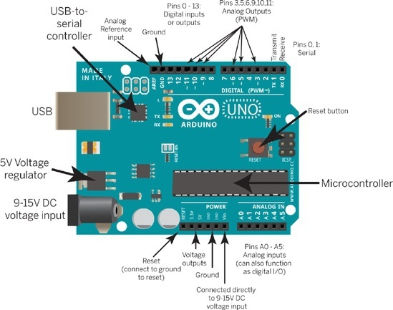
Step 2:

Pin configuration :
There are 32 pins in arduino to process the input signal of the program coded in the kit .Each has a different operating operation of the system depends upon the program is encoded to the system .after that when the input signal its operates according to that program implementation.
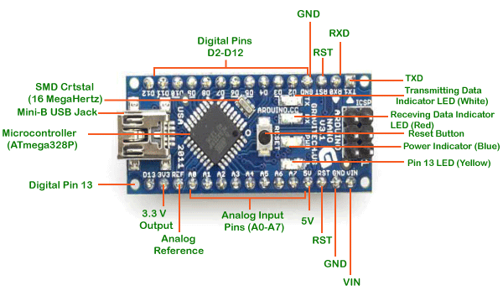

Step 3:
QR CODE SCANNER :
The scanners scans the amount and serial no of the product using scanner code and this input if given to arduino board pin by a serial connection .The scanner adapter is get connected to the arduino board connection and it implements the next processes.and it stores the input in the arduino.

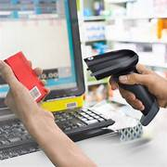

Step 4:
LCD DISPLAY:
The lcd display gives the ouput of the system which shows the serial no and exact amount of the product . which is already programmed to the lcd display thorugh c programming for supply on processes at 5v supply .

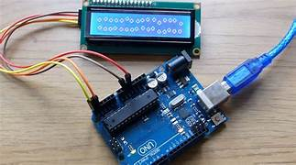

Step 6:

Final output of system :
The first input is given to arduino board when we scans the product and the scanner input is implemented to the arduino and the arduino process by the program and the processed input is given to the lcd display which is already embeded by the program and the lcd display shows the amount and serial no of the product in the trolley theses components were fixed in trolley for customer users to know the exact amount of the product and total products taken by the customers. If the product is removed from trolley the values changes in lcd display automatically.

